Chris Prabhu

Saranya Babuselvan

Neelayadhatchi (Neela) Sridharan

Alaind (Alli) Sklar

**Flying Dynamos: Suicide Among Veterans in the United States**

**Veteran vs. Non-veteran Suicides:**

Q: What is the rate of veteran suicides and how does that compare to non-veterans?

In our analysis, we found that veterans commit suicide at a much higher rate than the overall population. The bar graph shows that veterans take their own lives at about double the rate than non-veterans. On average, there are 22 veteran suicides per day.

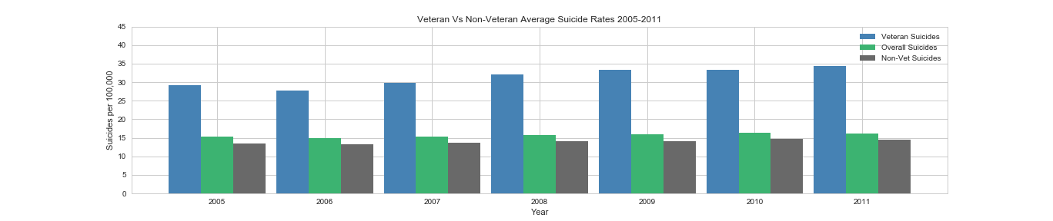

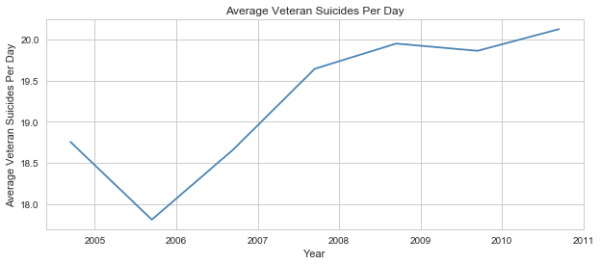

**Veteran Suicides by State & VHA Centers:**

Q: Which states have the most veterans’ death due to suicide and what is the total availability of Veteran Affairs (VA) medical centers in those high-risk states?

The four states with the highest suicide rates are Montana, Idaho, Nevada, and New Mexico. The suicide rates in these four states are at 50.74 (per 100,000 people) or higher, which is above the overall veteran suicide rate of 34.28 and the rest of the country at 31.02. These four states also have the less amount of VHA centers (1 center for Montana, Idaho, and New Mexico, and 2 centers for Nevada).

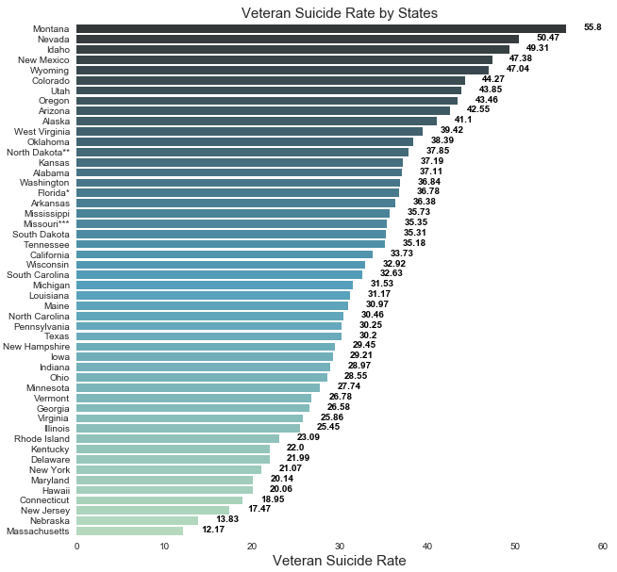

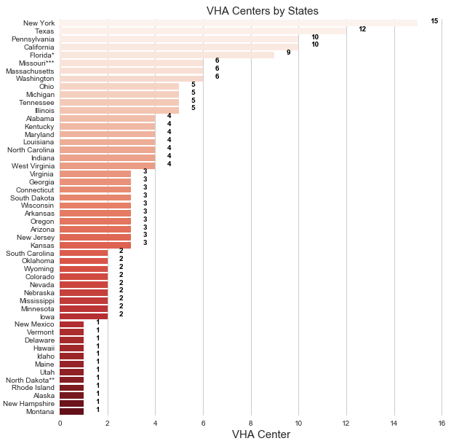

**Veteran Suicides by Age Group:**

Q: Which veteran age group(s) have the highest rate of suicide?

The risk of suicide is 19% higher among veterans compared to civilians. From 2005 to 2011, older veterans make up for most of military suicides—roughly 69% were age 55 or older.

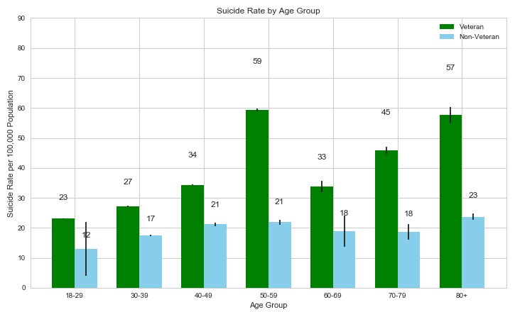

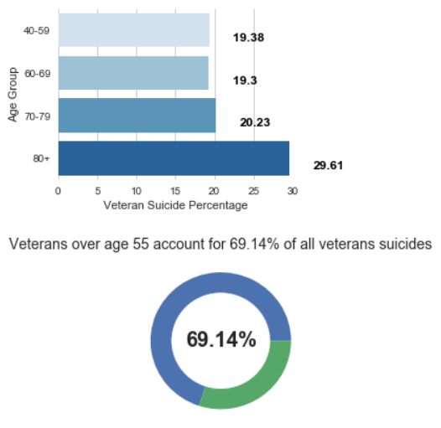

**Veteran Suicide by Gender:**

Q: Do male veterans have a higher rate of suicide than female veterans or vice versa?

There was noticeably a higher rate of suicide among male veterans than female veterans. The overall average rate of male suicides is about 43%. From 2005 to 2014, there was an increase of suicide rates in male veterans of 9.69%. Whereas, female veteran suicide rates have been consistent throughout the ten years with an overall average of 12.38%.

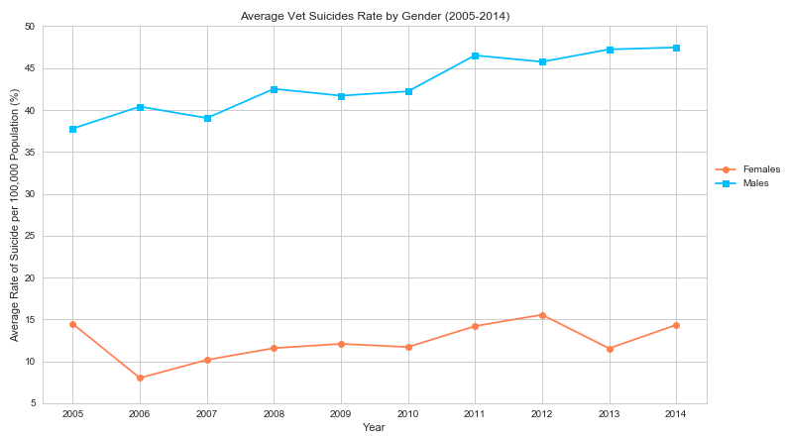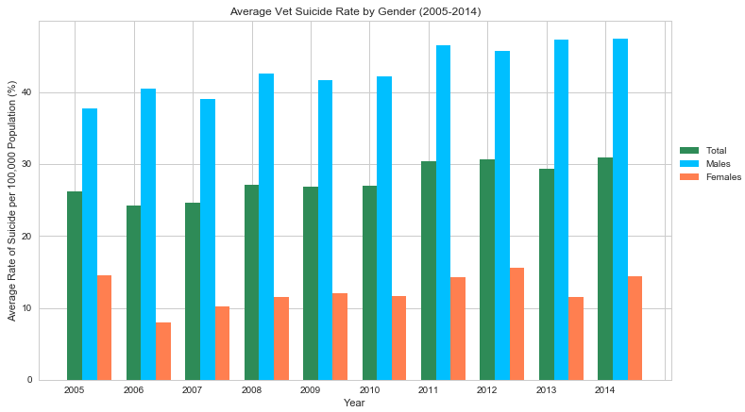

**Conclusion:**

Q: Is there a trend occurring with suicide related deaths among veterans and if there is one, is it increasing or decreasing?

All of our analysis shows that there is an increasing trend in veteran suicides. Some suggestions to combat this increase in veteran suicides are to:

* Encourage state and local officials to collaborate with mental health providers in both public and private sectors.
* Create more clinics in order to make it more accessible to veterans to receive professional help.
* Creating support groups and making veterans informed about seeking mental health assistance when needed.
* Developing better strategies for routine mental health screenings and early intervention for all service members before they return to civilian life.